Complex Engineering Problem Description and
Overview(D1)

Project Topic: Wireless Network Congestion in Densely Populated Areas

223124404
NN Sibambo

Figures
Figure 1 Typical Wireless Network Layout 4
Figure 2 High Density Wireless Environment 4
Figure 3 Wireless Signal Propagation 5
Figure 4 Load Imbalance in WiFi Networks 7
Figure 5 Network Traffic Flow 9
Figure 6 Campus Network Structure 10

Tables
Table 1 System Boundary Definition 3
Table 2 Stakeholders Affected 3
Table 3 Subsystem Interactions 5
Table 4 Conflicting Engineering Constraints 6
Table 5 User Requirements 7
Table 6 Requirement Trade-Offs 8
Table 7 Engineering Theory Required 8
Table 8 Resource and Lifecycle Constraints 10

Table of Contents
Figures 2
Tables 2
Problem Description 2
Argument For Engineering Complexity 5
Systems-Level Interactions 5
Conflicting Technical Constraints 5
User Requirements 7
Engineering Fundamentals and Scientific Underbuilt 8
Resource Use, Environmental Impact, and Lifecycle Considerations 9
References 11

Problem Description
Wireless local area networks allow devices such as laptops and mobile phones to connect to the internet using radio signals instead of cables. In universities these networks are essential for teaching activities such as programming laboratories, software installation sessions, and online learning.
During laboratory sessions it is common for many students to download the same software at the same time. When this occurs inside a lecture hall or computer laboratory, dozens of devices begin requesting data simultaneously. Each device automatically connects to the wireless router that provides the strongest signal strength.
This connection behavior often results in an uneven distribution of users across available routers. One router may become heavily loaded while other nearby routers remain lightly loaded. The overloaded router must divide its limited bandwidth among many users. This leads to extremely slow download speeds and very long waiting times.
The engineering problem is therefore defined as the inefficient distribution of wireless network traffic among multiple routers in a densely populated indoor environment, resulting in severe congestion and degraded network performance.
The problem is framed as an engineering problem because it involves the performance of a wireless communication system operating under physical and network constraints. The objective is to understand why the system behaves inefficiently under heavy load conditions.

Table 1 System Boundary Definition
System Element | Included | Reason
Student laptops and smartphones | Yes | Generate network traffic
Wireless access points (routers) | Yes | Provide wireless communication
Radio frequency communication channel | Yes | Medium for signal transmission
Building environment (walls, layout) | Yes | Influences signal strength and interference
System Element | Included | Reason
External internet backbone | No | Congestion occurs locally
Remote servers hosting downloads | No | Not responsible for local traffic imbalance

Table 2 Stakeholders Affected
Stakeholder | Impact
Students | Delayed downloads and interrupted learning
Lecturers | Reduced time for instruction
IT administrators | Increased network troubleshooting
University management | Infrastructure costs and upgrades

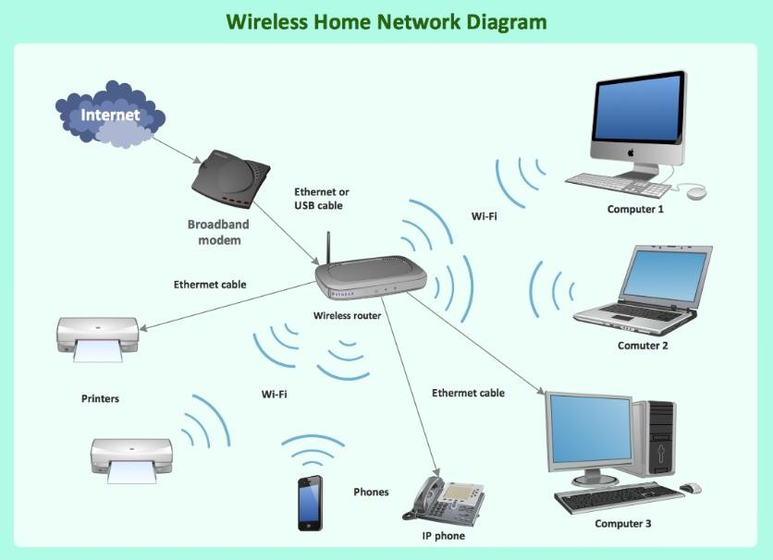
Figure 1 Typical Wireless Network Layout

This diagram illustrates how multiple wireless access points provide network coverage to many devices[1].
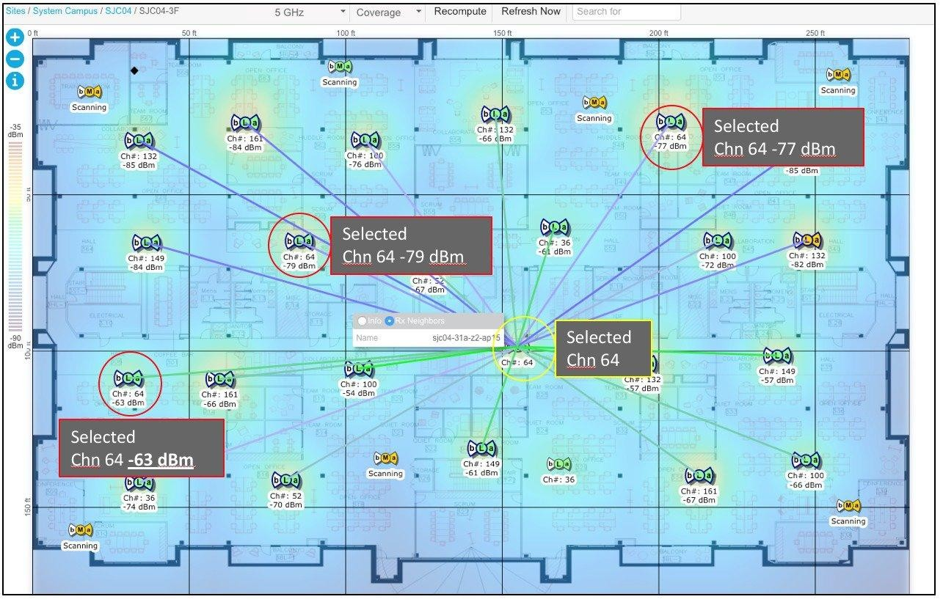
Figure 2 High Density Wireless Environment
This diagram shows multiple wireless users sharing a network infrastructure[2].

Argument For Engineering Complexity
According to the Engineering Council of South Africa, a complex engineering problem involves several interacting systems, conflicting constraints, and requires analysis using engineering fundamentals rather than simple rules or standard procedures [3].

Systems-Level Interactions
Wireless networks consist of several interacting components including user devices, access points, radio channels, and network protocols. The behavior of the entire system depends on how these components interact dynamically.

Table 3 Subsystem Interactions
Subsystem | Role
User devices | Generate network traffic
Access points | Distribute wireless bandwidth
Radio frequency channels | Carry signals between devices
Indoor environment | Causes signal attenuation and reflection
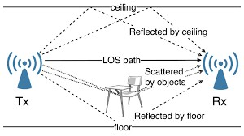
Figure 3 Wireless Signal Propagation
This diagram shows how radio signals propagate and weaken as distance increases[4].

Conflicting Technical Constraints
Wireless network design must balance several competing objectives.

Table 4 Conflicting Engineering Constraints
Objective | Engineering Conflict
High data throughput | May reduce fairness between users
Strong signal connection | May overload specific routers
Balanced traffic distribution | May require connection switching
Stable connections | May limit traffic redistribution
Because these objectives conflict with each other, the system cannot be optimized using simple configuration settings.
Requirement for First Principles Analysis
Analysis of this problem requires engineering laws and mathematical models.
One important principle is the Shannon–Hartley Theorem which defines the maximum theoretical data rate of a communication channel.
Shannon Capacity Equation
C = B log₂(1 + SNR)
Where
C = channel capacity in bits per second
B = channel bandwidth
SNR = signal to noise ratio
This law demonstrates that the capacity of a wireless channel is limited by bandwidth and signal quality [5].
When many users share the same channel, the available capacity must be divided among them, which leads to congestion.
Absence of Standard Solutions
Standard WiFi association algorithms rely mainly on signal strength. They do not account for router load or traffic congestion. As a result, devices may connect to an already overloaded router even when nearby routers have available capacity.
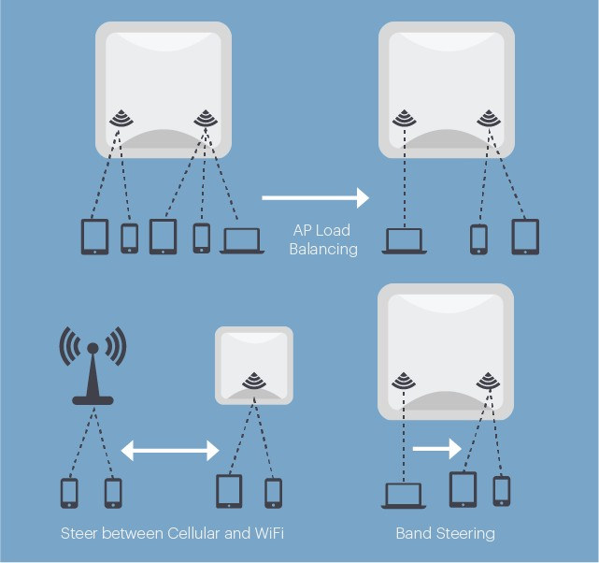
Figure 4 Load Imbalance in WiFi Networks

This diagram shows how some access points become overloaded while others remain underutilized[6].
These characteristics demonstrate that the problem requires detailed engineering analysis and cannot be solved using simple configuration adjustments.

User Requirements
User requirements describe the expected performance of the system. These requirements do not specify design choices but instead define measurable outcomes.

Table 5 User Requirements
Requirement  ID | Requirement | Measurement
UR1 | Support large number of simultaneous users | Number of connected devices
UR2 | Maintain acceptable download speed | Average download time
UR3 | Ensure balanced distribution of users across routers | Number of users per router
UR4 | Maintain stable wireless connections | Connection drop rate
UR5 | Operate within existing campus infrastructure | Compatibility verification
UR6 | Minimize energy consumption of user devices | Device battery usage

Table 6 Requirement Trade-Offs
Requirement | Potential Conflict
High throughput | May reduce fairness
Load balancing | May cause reconnection delays
Connection stability | May reduce traffic optimization
Low energy consumption | May limit communication overhead
Because these requirements influence each other, satisfying them simultaneously requires complex engineering analysis.

Engineering Fundamentals and Scientific Underbuilt
Several engineering disciplines are required to understand the problem.

Table 7 Engineering Theory Required
Field | Application
Electromagnetic theory | Explains wireless signal propagation
Wireless communication theory | Determines data transmission limits
Information theory | Defines maximum channel capacity
Computer networking | Explains packet routing and congestion
Queueing theory | Models delays under heavy traffic
Graph theory | Represents network topology

Definition: Queueing Theory
Queueing theory studies systems where multiple users compete for limited resources. In communication networks it explains how packet delays increase as traffic demand approaches channel capacity [7].

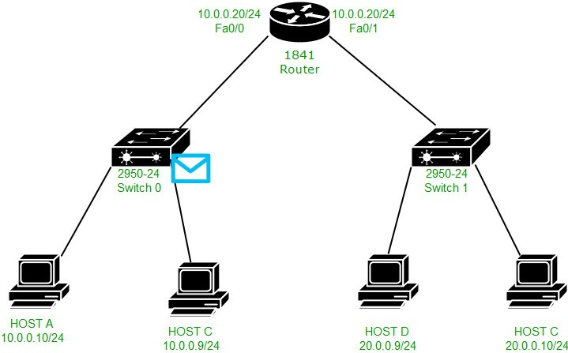
Figure 5 Network Traffic Flow

This diagram illustrates how traffic flows through routers and communication links[5].

Resource Use, Environmental Impact, and Lifecycle Considerations

Engineering solutions must consider resource usage and long term sustainability.

Table 8 Resource and Lifecycle Constraints
Constraint | Impact
Hardware cost | Adding routers increases infrastructure expense
Energy consumption | Congestion causes repeated transmissions
Maintenance complexity | Advanced systems require skilled technicians
Scalability | Network must support future growth
Equipment lifespan | Infrastructure should operate for many years
Reducing congestion through better resource utilization may extend the lifespan of existing infrastructure and reduce energy consumption.

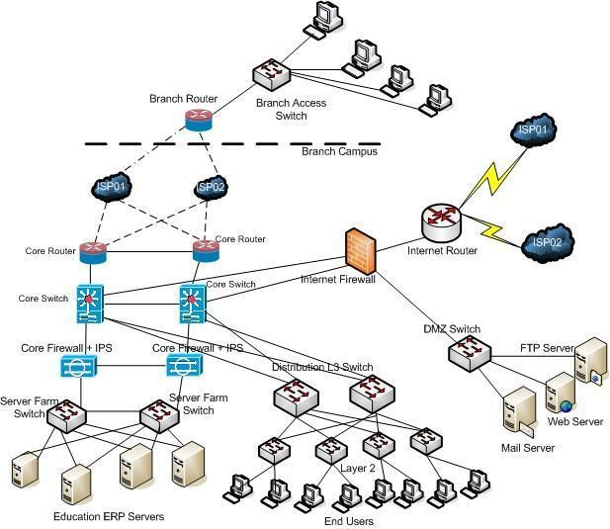
Figure 6 Campus Network Structure

This diagram illustrates the structure of large campus networks[8].

References
- Wireless LAN topology diagram, Wikimedia Commons. Available:
https://upload.wikimedia.org/wikipedia/commons/6/6e/Wireless_LAN_topology.png
- WLAN network architecture, Wikimedia Commons. Available: https://upload.wikimedia.org/wikipedia/commons/8/84/WLAN_Network_Architecture.png
- Engineering Council of South Africa, Accreditation Standard for Engineering Programmes.
- Radio signal propagation diagram, Wikimedia Commons. Available: https://upload.wikimedia.org/wikipedia/commons/2/21/Radio_signal_propagation.png
- C. E. Shannon, “A Mathematical Theory of Communication,” Bell System Technical Journal, 1948.
- L. Kleinrock, Queueing Systems Volume 1: Theory, Wiley.
- Computer network topology diagram, Wikimedia Commons. Available:
https://upload.wikimedia.org/wikipedia/commons/5/5b/Computer_network_topology.png
- Enterprise network architecture diagram, Wikimedia Commons. Available: https://upload.wikimedia.org/wikipedia/commons/3/3c/Enterprise_network_architecture. png

